Zach Tucker
Emotion in the Arts, PHIL2054
19 Jan 2014

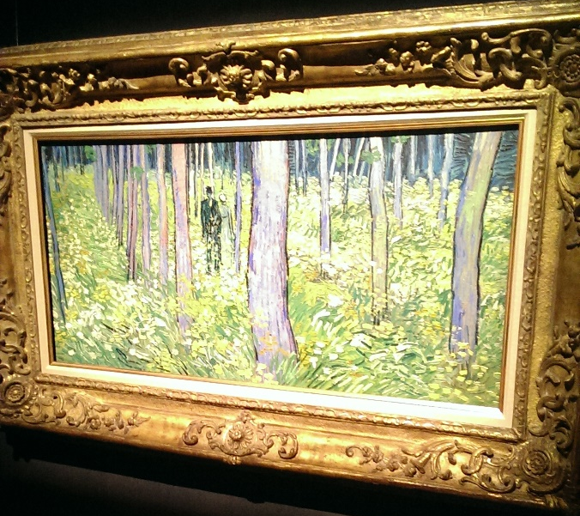  Figure 1: Clive Bell (Significant Form) - Undergrowth With Two Figures - Vincent Van Gogh – 1890 | 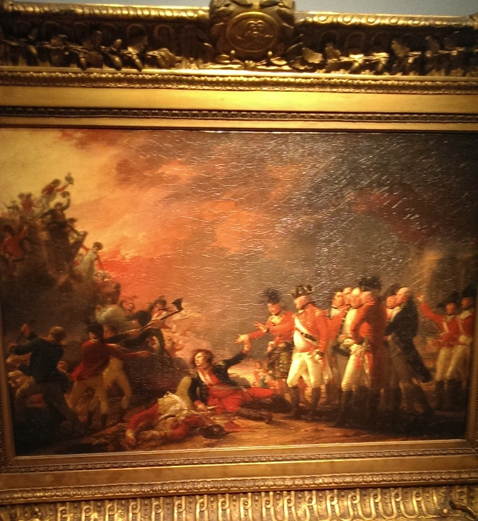  Figure 2: Leo Tolstoy (communication of emotions) - The Sortie Made by the Garrison of Gibraltar - John Trumbull - 1788

Van Gogh’s Undergrowth With Two Figures (Figure 1) is a good representation of Clive Bell’s view that art is distinguished by significant form. The painting is unified by a largely similar color palette. The brush strokes are remarkably similar

